**TAHAPAN MEMBUAT PROJECT CI3**

1. **Konfigurasi**

Application/config/..*here*.../

.htaccess :

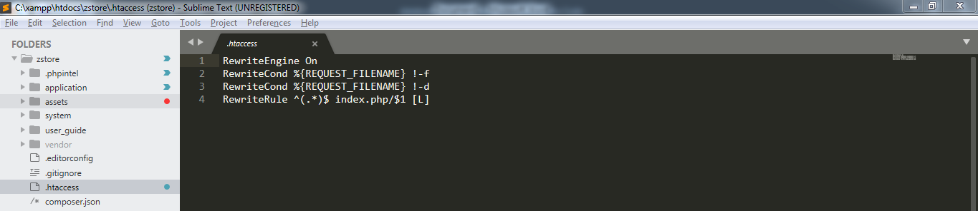

Autoload.php

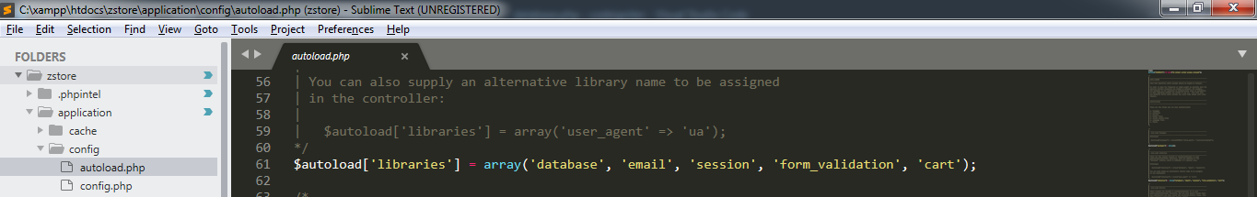

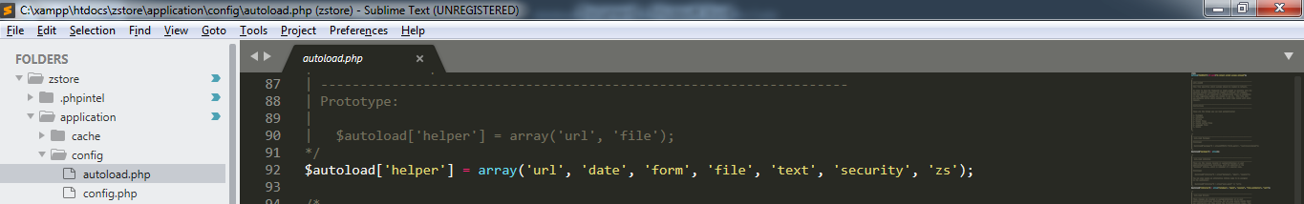

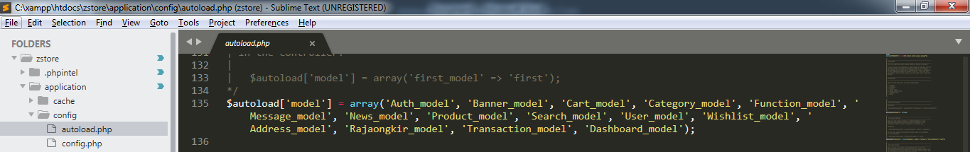

Config.php

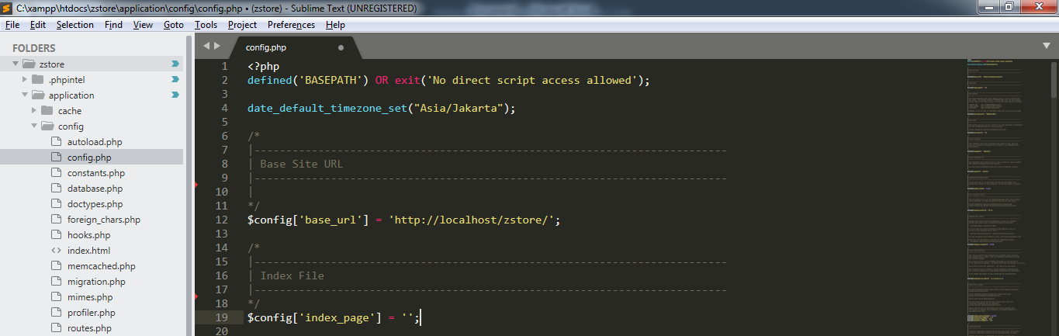

Database.php

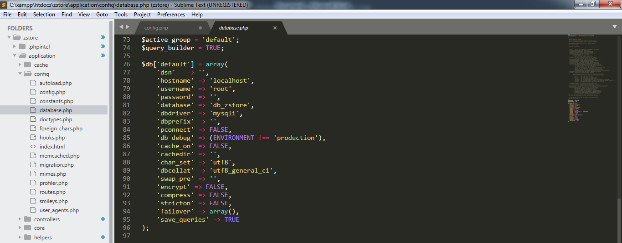

Routes.php

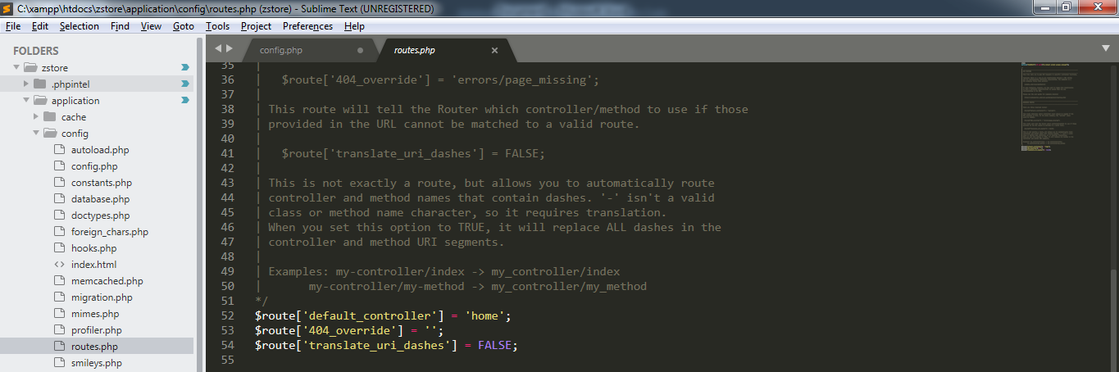

1. **MVC**

Controller

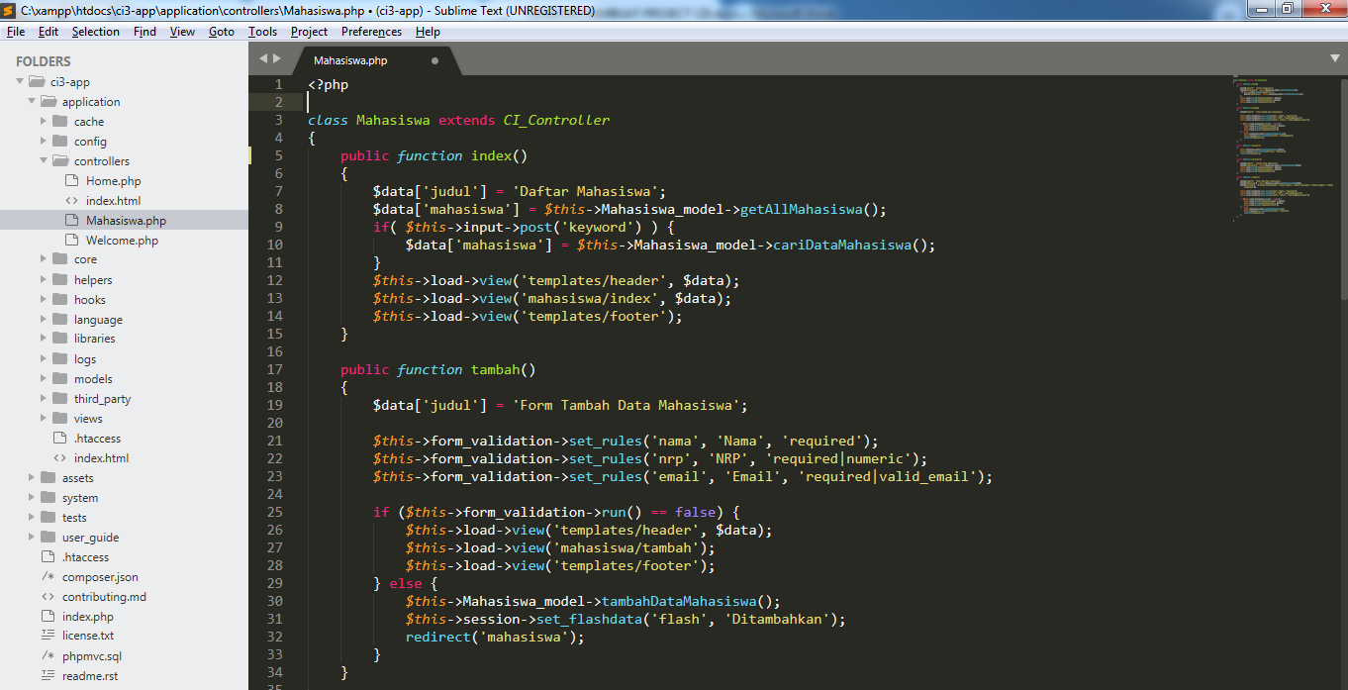

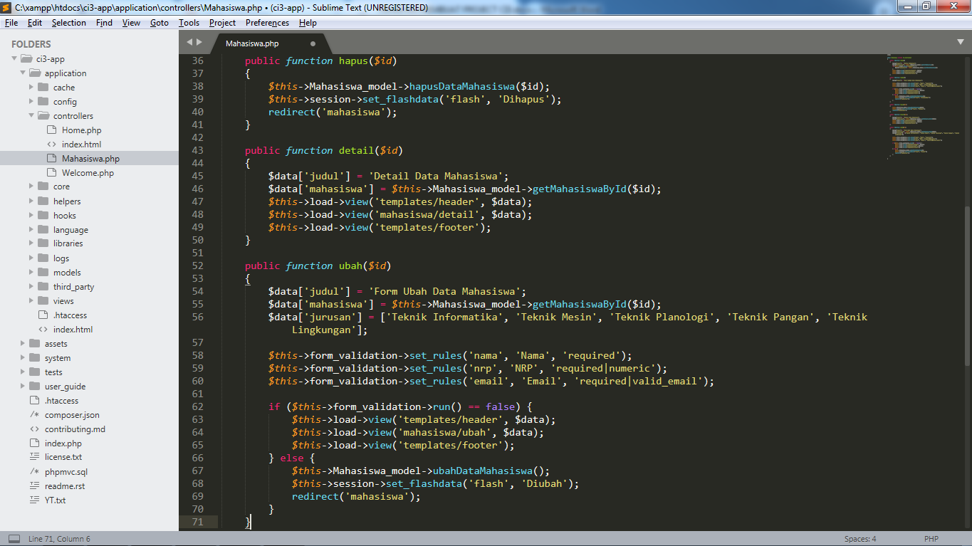

Model

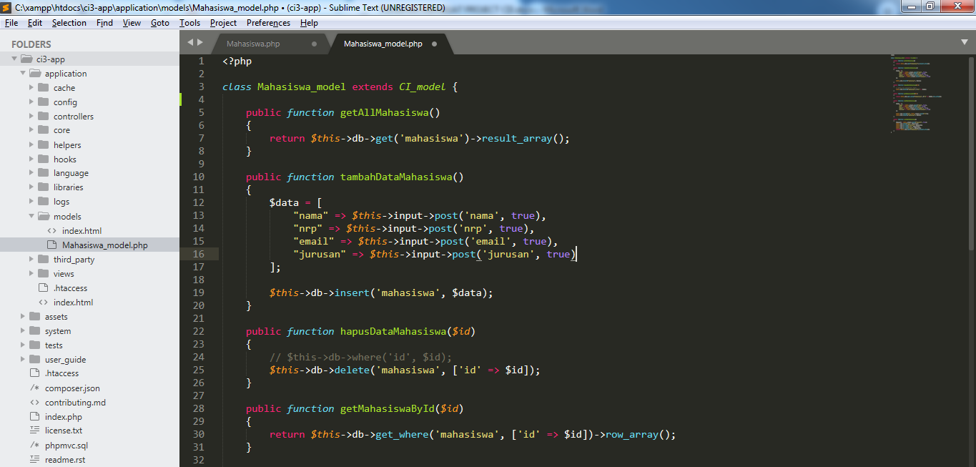

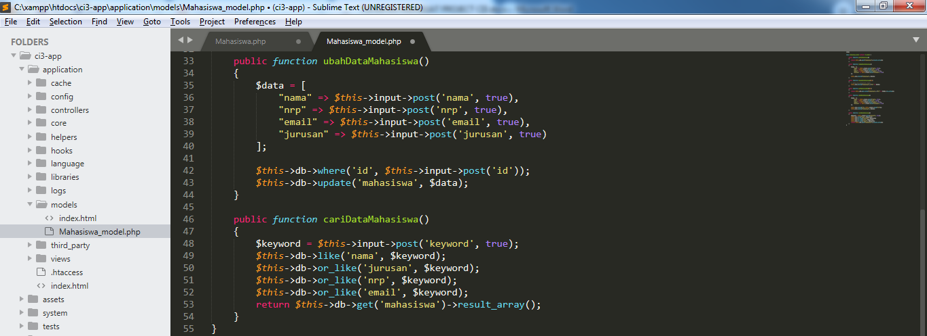

View

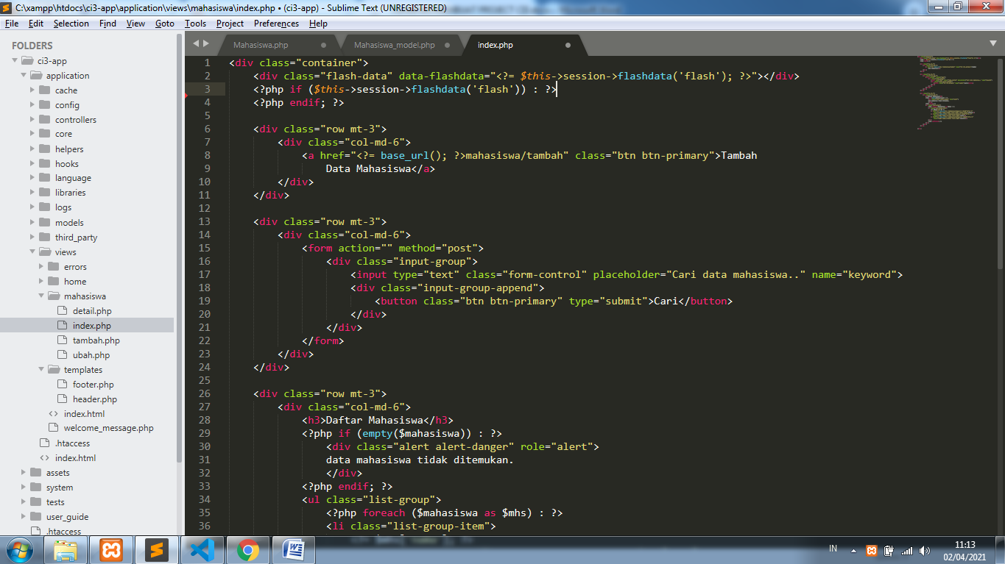

1. **CRUD**

Create

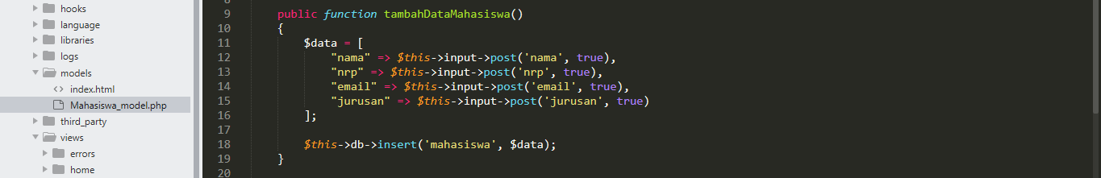

Read

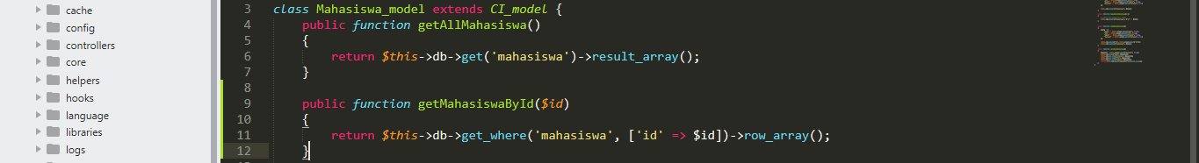

Update

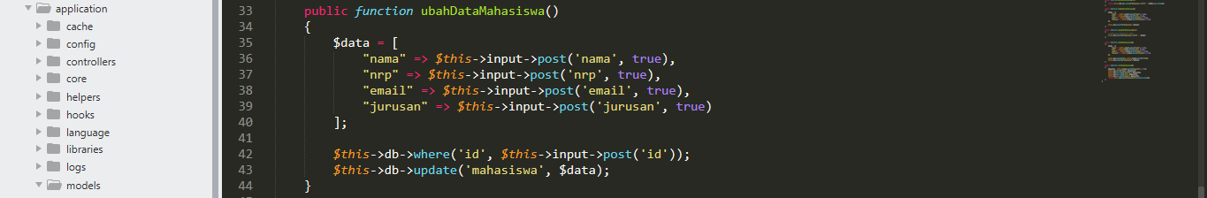

Delete



Search

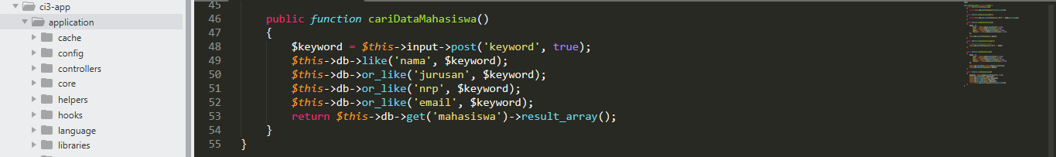

1. **Features**

Function_model (load view singkat)

